Attachment 2
Concur Request Workflow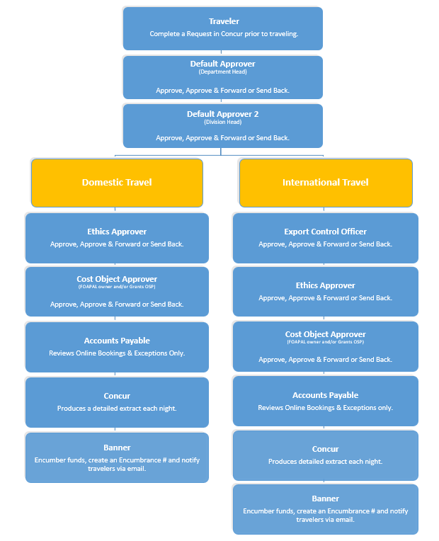

Attachment 3
Concur Expense Report Workflow
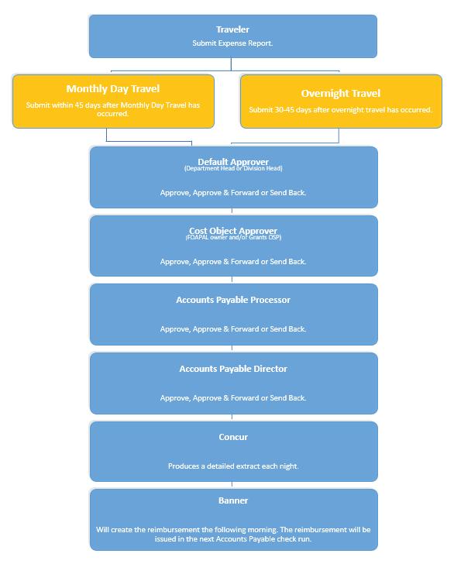

Attachment 4
Student/Non-Employee Domestic Travel Request Paper-Based Process
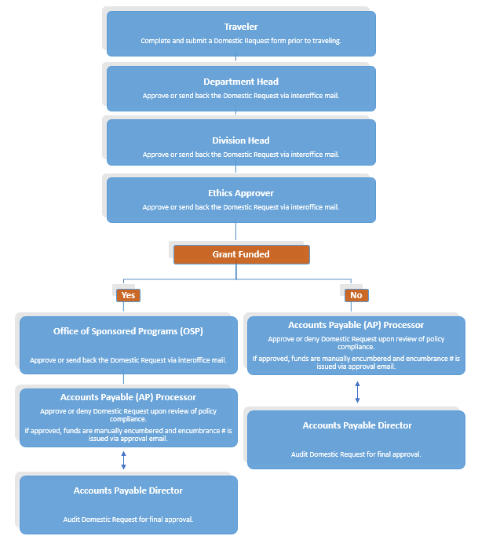

Attachment 5
Student/Non-Employee International Travel Request Paper-Based Process
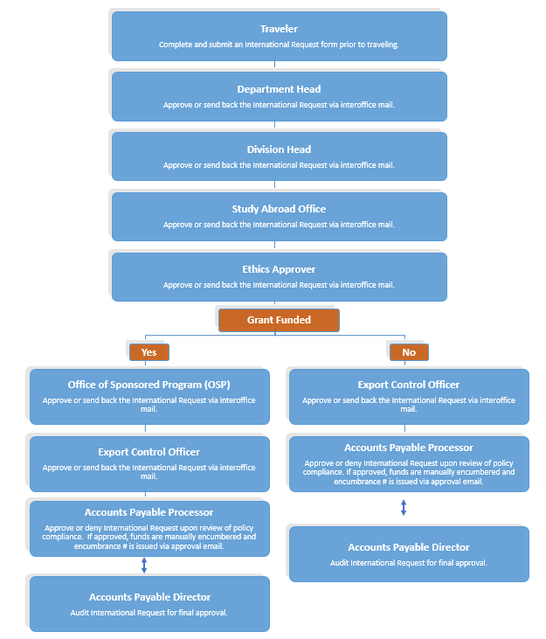

Attachment 6
Student/Non-Employee Travel Expense Paper-Based Process
